**Project 02_06_02**

In this Project we will build a PHP application to test our knowledge of the unit. Be sure to document all of your code to indicate your understanding.

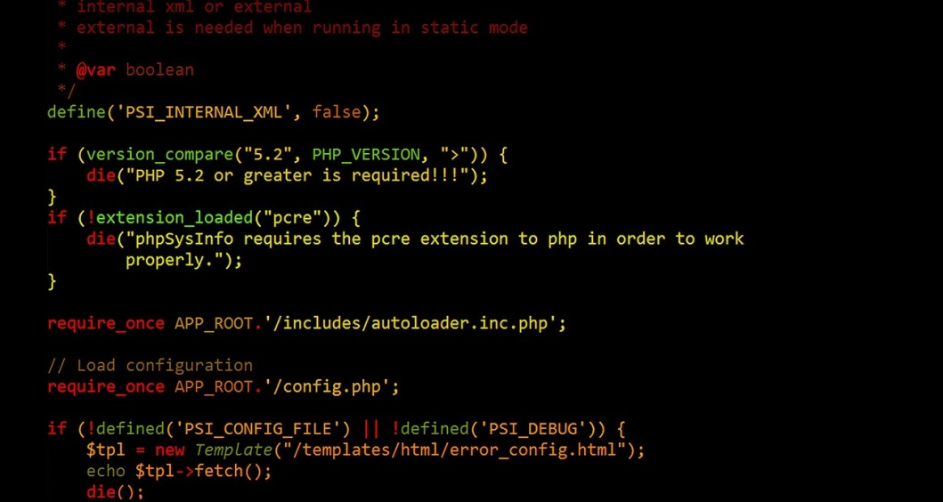 

In this Project, you will create two PHP scripts to create an online Order Form.

Use a PHP script named ***PostOrders.php*** as a Web form that allows visitors to enter a quantity for up to at least five items for sale. The items should be hardcoded into an array of delimited text. Each item should have a name, description, and price. You should provide a field to have the total of each item. It stores the data in a text file named ***Orders.txt***. The form will need reset and submit buttons. Include a link that allows users to view the orders on file (see next script specification). You are expected to provide a form that has a nice appearance, so use some good spacing, and add a little CSS to accomplish that. It will affect the Professionalism and Technique parts of your grade.

Use a PHP script named **OnlineOrders.php** to display and process the order data. You will need to provide a link back to PostOrders.php. You will also need to provide functionality to delete any individual order. Be sure to provide some professional looking output.